Project Executable Files
Date | 10/07/2026
Name | SYED MOHAMMAD KHAJA
Project Name | Credit Card Approval Prediction
Maximum Marks | 3 Marks

Project Executable Files:
This section contains all executable and deployable files required to run the Credit Card Approval Prediction project. The project is built using Python and machine learning libraries to predict whether a credit card application should be approved or rejected based on applicant details. The solution includes the trained ML model, source code, datasets, and documentation for easy deployment and execution.
Step 1: Submission Checklist
S.No | Item to Submit | Submitted (Yes / No / NA)
1 | Complete source code (all files and folders) | Yes
2 | README / Setup Guide | Yes
3 | requirements.txt / dependency file | Yes
4 | Database schema / seed files | NA
5 | Environment configuration (.env.example) | No
6 | Hosted / Deployed Application URL | No
7 | APK / Executable Binary | NA
8 | Dockerfile / Containerization config | No
9 | Test files and test results | Yes
10 | Demo Video / Walkthrough | Yes
Step 2: File / Folder Structure
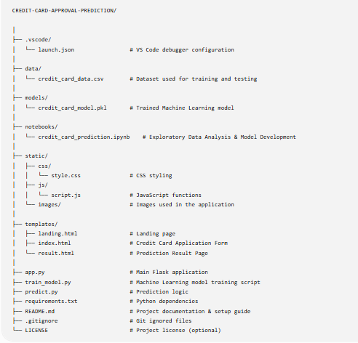
Step 3: Deployment / Access Details
Field | Details
Hosted / Deployed URL | Not Hosted
Login Credentials | Not Required
Platform / Hosting Provider | Local Machine (Python + Flask)
Repository Link | https://github.com/KhajaSyed45/Credit-Card-Approval
Live Demo | https://credit-card-approval-2-tgcz.onrender.com

Step 4: Run Instructions
- Clone or download the Credit Card Approval Prediction project repository.
- Install the required Python dependencies using requirements.txt.
- Run the Flask application using app.py.
- Open your web browser and navigate to http://127.0.0.1:5000
- Enter the applicant details (Age, Annual Income, Employment Duration, Payment Status, Credit Inquiries, etc.) and click Predict.
- View the Credit Card Approval Prediction result (Approved/Rejected) displayed on the result page.

Step 5: Known Issues / Limitations
S.No | Known Issue | Workaround / Status
1 | Runs locally using Flask only | Can be deployed on Render, AWS, or Azure
2 | Uses CSV dataset instead of a live banking database | Future enhancement can integrate MySQL/PostgreSQL
3 | No user authentication or login module | Authentication can be added in future versions using Flask-Login or JWT

